**"TO STUDY THE ELECTRICITY CONSUMPTION PATTERN IN NEPAL"**

**A PROJECT WORK SUBMITTED FOR THE PARTIAL FULFILLMENT OF THE REQUIREMENT FOR THE GRADE 11 SCIENCE IN PHYSICS**

**By**

**Name:**

**Grade:**

**Roll No:**



**National Academy of Science and Technology(NAST)**

**National Education Board(NEB)**

**Dhangadhi, Kailali, Nepal**

**Date:**

**CERTIFICATE OF APPROVAL**

The project work entitled "STUDY OF ELECTRICITY CONSUMPTION PATTERN IN NEPAL" by Mr. __________________________ under the supervision of Mr. _________________________Of______________________________________________________________________ , Nepal, is hereby submitted for the partial fulfillment of requirement of Physics in Grade 11. This project work has not been submitted in any other school or institution previously for the award of Grade 11.

__________________________________________ __________________________________________

Supervisor: Head of the Department:

**Mr. Hari Datta Pant Mr. Krishna Singh Bhandari**

Department of Physics Department of Science

National Academy of Science National Academy of Science

and Technology(NAST) and Technology(NAST)

**DECLARATION**

I, ­­­­­­­­­­­­___________________ hereby declare that the project work entitled, "STUDY OF ELECTRICITY CONSUMPTION PATTERN IN NEPAL" under the supervision of Mr.________________________Of____________________________________________________________________________ , Nepal, presented herein is genuine work done originally by me and has not been published or submitted elsewhere for the requirement of any degree program. Any literature, data or works done by others and cited in this project work has been given due acknowledgement and listed in the reference section.

_______________________

Grade:

E-mail address:

Date:

**TABLE OF CONTENTS**

**Chapter 1: Introduction to Electricity**

**Chapter 2: Electricity Consumption in Nepal**

**Chapter 3: Sources of Electricity Consumption in Nepal**

**Chapter 4: Conclusion**

**Chapter 5: Acknowledgement**

**Chapter 6: References**

1. **Introduction to Electricity:-**

Electricity is one of the most important factors required to increase economic growth, human development is closely related to the quality of life in rural areas. Household’s electricity consumption was investigated in winter and summer season of western part of rural area of Nepal. Some research papers and reports ware reviewed concerning to electricity consumption, GDP and CO2 emission. We conducted a field survey with a sample of 300 households in the total population 16,272 of Raskot Municipality of Kalikot, Nepal. We have collected electricity bills, family income and family size. The electricity consumption, GDP and CO2 emission were highly correlated. The electricity consumption was found to be 25.7 kWh/capita/year. The average electricity consumption was highly related to family size. This study would be helpful to know the electricity consumption system and its management in the rural areas of Nepal and to policy making for electricity production, consumption and reduce CO2 emission.

1. **Electricity Consumption in Nepal:-**

As Nepal Electricity Authority (NEA) annual report 2013 describes that Nepal has 762,029 kWh of electricity available but currently 40% of the population has access to electricity, and the rural electrification accounts for only 29% (KC et al. 2011) which is considerably low compared to other countries in the world. The energy consumption in Nepal is below than basic human needs and lowest in the world. Malla (2013) urged that 87% of Nepal total energy is consumed by households. Parajuli et al. (2014) also describe the total primary energy consumption and electricity consumption, both are significantly dependent with total GDP and population growth. They estimated in business and usual the electricity consumption in 2030 would be 7.97 TWh (terawatt per hour), which is 3.47 times higher than the of 2009.

The electricity consumption rate of rural areas of Nepal was 19.5 kWh/capita/year (Shahi et al. 2017) that is very low as compared to national (128.148 kWh/capita/year) and global (3,104.382 kWh/capita/year) electricity consumption rate (The World Bank, 2013). The different electricity consumption patterns were successfully discovered and their corresponding characteristic indicators were identified many households in China have similar monthly electricity consumption pattern Kaile et al. (2017). The prevailing researches have given emphasis on firewood energy, gasses, fossil oil and electricity in general. But none of the researches have investigated related with electricity consumption and family income, family size in rural households of Nepal. The geographically and economically can be occurs in use of electricity which created many changes in production, consumption and distribution of electricity energy.

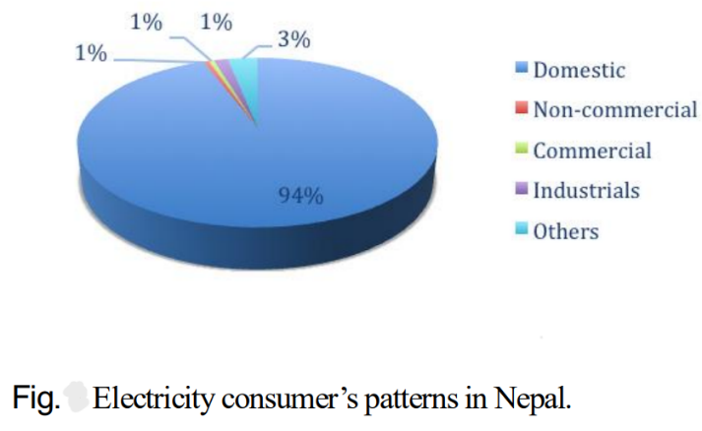

1. **Source of Electricity Consumption in Nepal:-**
2. **Hydropower:**

Hydropower plays a predominant role in Nepal’s electricity system. Currently, 96.2% of the installed capacity is from hydropower.

Hydropower has been recognized as a sustainable source of energy with almost zero input cost. Its benefits are that it is non-polluting in the sense that it releases no heat or noxious gases, it has low operating and maintenance cost, its technology offers reliable and flexible operation, and hydropower stations have increased efficiencies along with long life. Nepal's huge potential in hydropower is still untapped.

1. **Thermal Power:**

Electricity genrated by thermal power plant in which steam is used to produce work in turbine and by using this work electricity is gengenrated.

About 29 geothermal springs has been identified in [Nepal](https://en.wikipedia.org/wiki/Nepal) mostly located in the banks of Mahakali, Karnali, Tila, Kaligandaki, Myagdi, Marshyangdi, Trishuli, and Bhotekoshi rivers. Twenty three of them are officially recognized by the Nepal government. The source of heat is the Main Central Thrust.

1. **Import from India:**

Since the country currently has just one reservoir-based power project, Kulekhani, it has been difficult to boost supply during winter, officials said.

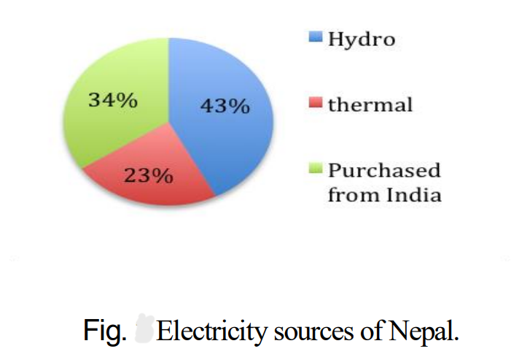According to the NEA, on Wednesday, it purchased[1,969 megawatt](https://nea.org.np/) hours of electricity from India and sold 661 megawatt hours to the southern neighbour.

1. **Conclusion:-**

From this study, we get to know about the electricity consumption pattern in Nepal. From this study, we came to know that Nepal is rich in high electricity producing hydropower plants although its implementation has still not been done. It also heavily depends upon India for electricity import which is not satisfactory as having own resources. So, the implementation of hydropower should be done wisely and intelligently for the progress of Nepal. This is the main conclusion of this study.

1. **Acknowledgement:-**

I would like to express my special thanks of gratitude to my teacher Mr. ________________________ as well as our principal Mr. ___________________________ who gave us the golden opportunity to do this wonderful project on the topic “STUDY OF ELECTRICITY CONSUMPTION PATTERN IN NEPAL”, which also helped me in doing a lot of research and I came to know about so many new things I am really thankful to them.

Secondly, I would like to thank my parents and friends who helped me a lot in finalizing this project within the limited time frame.

1. **References:-**

* [www.wikipedia.com](http://www.wikipedia.com)
* [www.kathmandupost.com](http://www.kathmandupost.com)
* [www.nepaleconomicforum.org](http://www.nepaleconomicforum.org)